Bits on the Track

There are four trains (identified by the characters **#**, **$**, **@**, and **+**) that start out on the westernmost stations in the railway map below. The circles are stations. Guide each train to its terminus station, identified by the train character bracketed by square brackets. For example, the terminus station for train # is [#], which is in the topmost row of stations, second from the West. Trains must past through *exactly* those stations that list their identifying characters. If a train must pass west-to-east through a station, this is indicated by the **>** suffix. If the train must pass east-to-west through a station, this is indicated by the **<** prefix.

You control the point system of the railway network. Carefully guide each train using the junction points (switches) so that it passes through exactly those stations it must visit, ending in its terminus station. According to the railway manual, if a train is at a junction point and must take the left track (relative to *its direction of travel*) mark this as a **0**, and if it must take the right track, mark this as a **1**. In this way, each junction point visited by a train generates either a 0 or a 1. Tracks merging in from elsewhere do not count as junction points. Every train ends up generating a 7-digit sequence. To get you started, at the first junction point visited by train #, the train takes the *right* track and so it generates a 1 (had it gone straight it would have generated a 0).

Final words of advice: common mistakes by beginning point operators are to miss junctions and forget that the left/right track designation is relative to the direction of train travel, not absolute (east/west) direction. Happy operating!

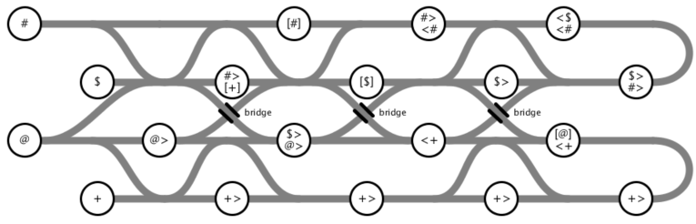

Answer: @ $ + @ $ #